1.Complete the Singleton class in your editor which contains the following components:
- A private Singleton non parameterized constructor.
- A public String instance variable named .
- Write a static method named getSingleInstance that returns the single instance of the Singleton class.
Once submitted, our hidden Solution class will check your code by taking a String as input and then using your Singleton class to print a line.
Java code
import java.util.*;
class Singleton {
public String str;
private static Singleton singleInstance = null;
private Singleton() {
}
public static Singleton getSingleInstance() {
if (singleInstance == null) {
singleInstance = new Singleton();
}
return singleInstance;
}
}
public class Solution {
public static void main(String[] args) {
Scanner sc = new Scanner(System.in);
String input = sc.nextLine();
Singleton s = Singleton.getSingleInstance();
s.str = input;

System.out.println("Hello I am a singleton! Let me say " + s.str + " to you");
sc.close();
}
}
Output
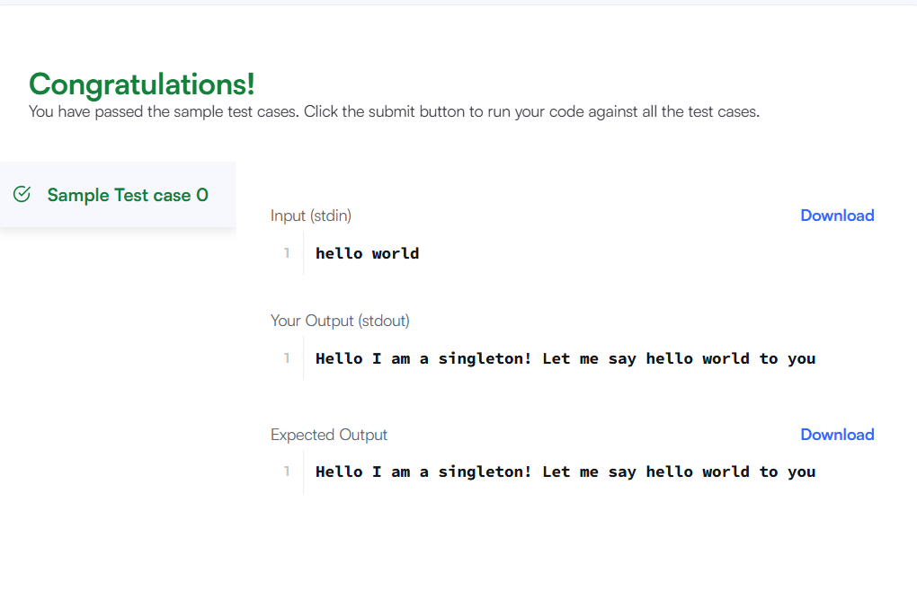
2. According to Wikipedia, a factory is simply an object that returns another object from some other method call, which is assumed to be "new".
In this problem, you are given an interface Food. There are two classes Pizza and Cake which implement the Food interface, and they both contain a method getType().
The main function in the Main class creates an instance of the FoodFactory class. The FoodFactory class contains a method getFood(String) that returns a new instance of Pizza or Cake according to its parameter.
You are given the partially completed code in the editor. Please complete the FoodFactory class.
Java code
import java.util.*;
interface Food {
String getType();
}
class Pizza implements Food {
public String getType() {
return "Someone ordered a Fast Food!";
}
}
class Cake implements Food {
public String getType() {
return "Someone ordered a Dessert!";
}
}
class FoodFactory {
public Food getFood(String order) {
if (order.equalsIgnoreCase("pizza")) {
return new Pizza();
} else if (order.equalsIgnoreCase("cake")) {
return new Cake();
}
return null;
}
}
public class Solution {
public static void main(String[] args) {
Scanner sc = new Scanner(System.in);
String order = sc.nextLine();
FoodFactory factory = new FoodFactory();
Food food = factory.getFood(order);
System.out.println("The factory returned class "
+ food.getClass().getSimpleName());
System.out.println(food.getType());

sc.close();
}
}

Output
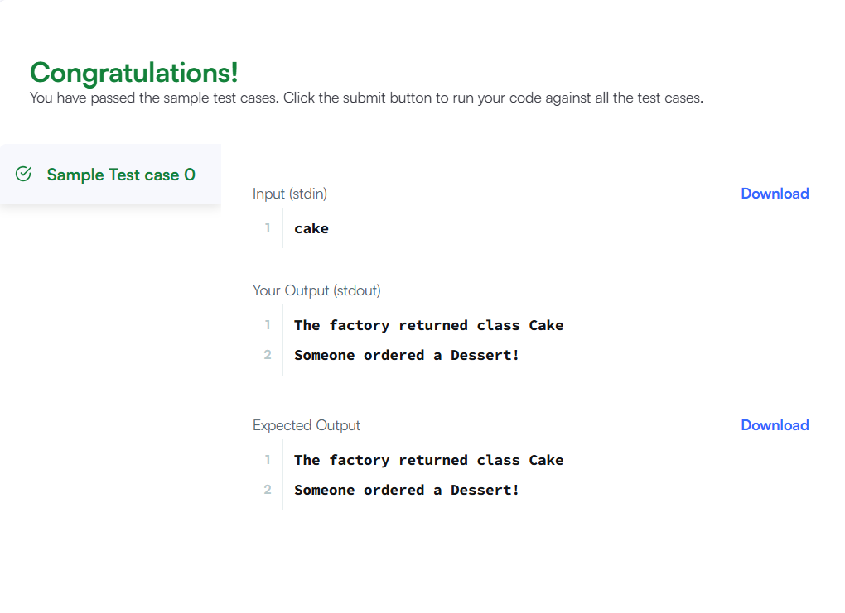
3. You are given a class Solution and its main method in the editor.
Your task is to create the class Add and the required methods so that the code prints the sum of the numbers passed to the function add.
Java code
import java.util.*;
class Add {
public void add(int... nums) {
int sum = 0;
StringBuilder sb = new StringBuilder();
for (int i = 0; i < nums.length; i++) {
sum += nums[i];
if (i > 0) {
sb.append("+");
}
sb.append(nums[i]);
}

sb.append("=").append(sum);
System.out.println(sb.toString());
}
}
public class Solution {
public static void main(String[] args) {
Scanner sc = new Scanner(System.in);
Add add = new Add();
int[] nums = new int[6];
for (int i = 0; i < 6; i++) {
nums[i] = sc.nextInt();
}
add.add(nums[0], nums[1]);
add.add(nums[0], nums[1], nums[2]);
add.add(nums[0], nums[1], nums[2], nums[3], nums[4]);
add.add(nums[0], nums[1], nums[2], nums[3], nums[4], nums[5]);
sc.close();
}
}
Output
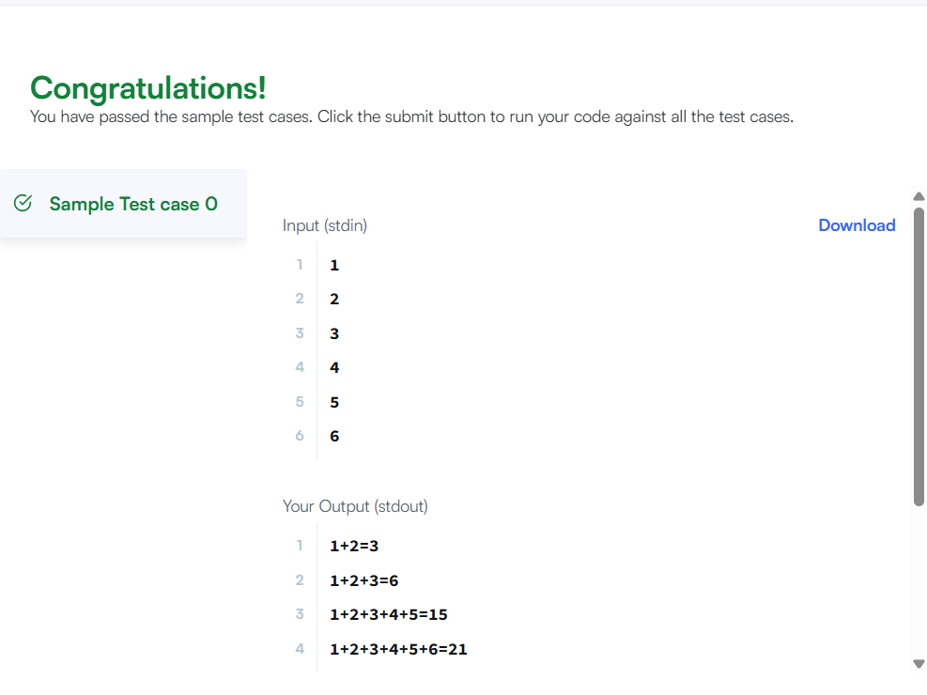

4. You are required to compute the power of a number by implementing a calculator. Create a class MyCalculator which consists of a single method long power(int, int). This method takes two integers, and , as parameters and finds . If either or is negative, then the method must throw an exception which says "". Also, if both and are zero, then the method must throw an exception which says ""
For example, -4 and -5 would result in .
Complete the function power in class MyCalculator and return the appropriate result after the power operation or an appropriate exception as detailed above.
Java code
import java.util.*;
class MyCalculator {
public long power(int n, int p) throws Exception {
if (n < 0 || p < 0) {
throw new Exception("n or p should not be negative.");
}
if (n == 0 && p == 0) {
throw new Exception("n and p should not be zero.");
}
return (long) Math.pow(n, p);
}
}
public class Solution {
public static void main(String[] args) {
Scanner sc = new Scanner(System.in);
MyCalculator calculator = new MyCalculator();
while (sc.hasNextInt()) {
int n = sc.nextInt();
int p = sc.nextInt();
try {
System.out.println(calculator.power(n, p));
} catch (Exception e) {
System.out.println(e);
}
}
sc.close();
}
}
Output

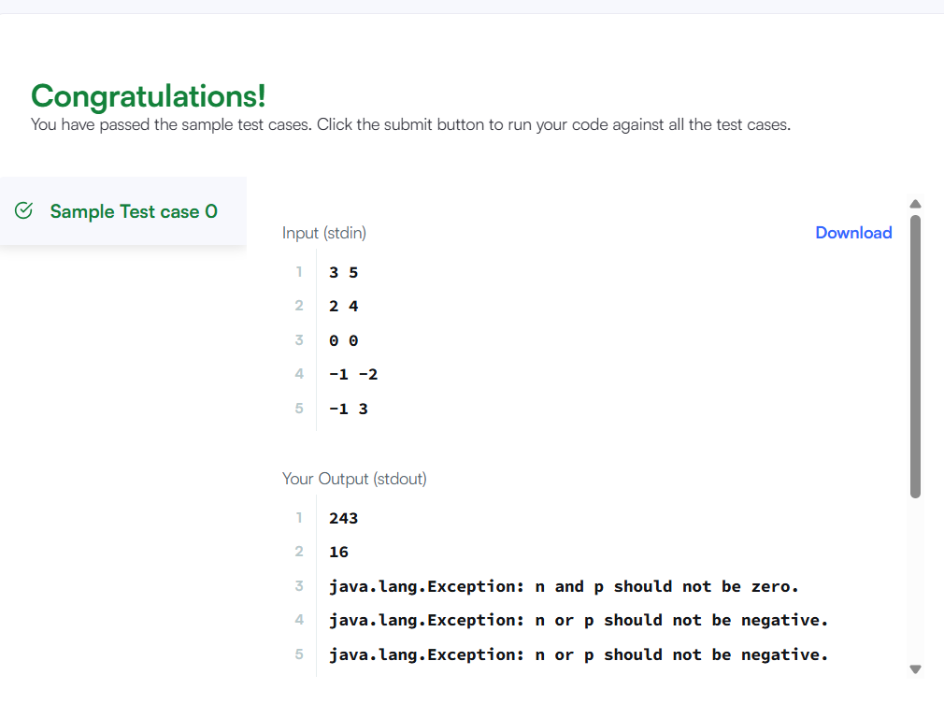
5. Exception handling is the process of responding to the occurrence, during computation, of exceptions – anomalous or exceptional conditions requiring special processing – often changing the normal flow of program execution. (Wikipedia)
Java has built-in mechanism to handle exceptions. Using the try statement we can test a block of code for errors. The catch block contains the code that says what to do if exception occurs.
This problem will test your knowledge on try-catch block.
You will be given two integers and as input, you have to compute . If and are not bit signed integers or if is zero, exception will occur and you have to report it. Read sample Input/Output to know what to report in case of exceptions.

Java code
import java.util.*;
public class Solution {
public static void main(String[] args) {
Scanner sc = new Scanner(System.in);
try {
int x = sc.nextInt();
int y = sc.nextInt();
System.out.println(x / y);
} catch (InputMismatchException e) {
System.out.println("java.util.InputMismatchException");
} catch (ArithmeticException e) {
System.out.println("java.lang.ArithmeticException: / by zero");
}
sc.close();
}
}

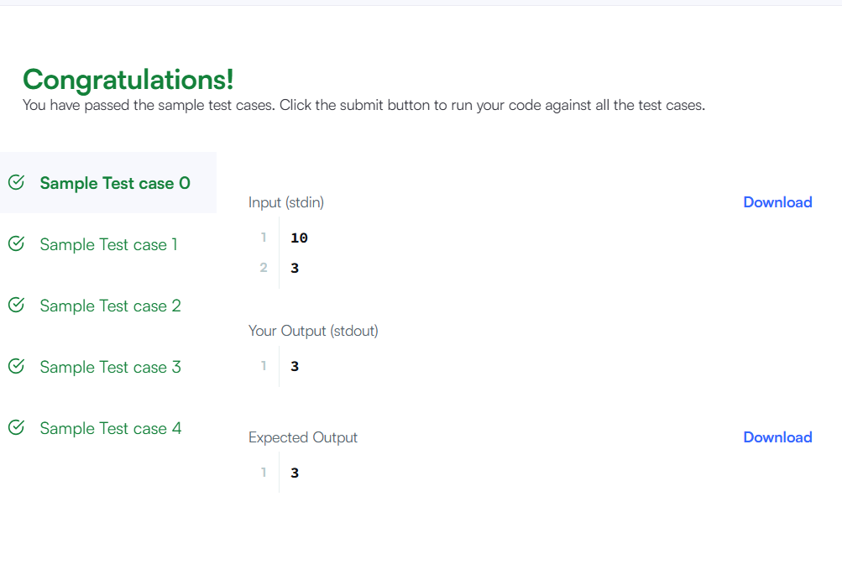
Output

6. Java Iterator class can help you to iterate through every element in a collection.
Java code
import java.util.*;
public class Solution {
static Iterator func(ArrayList mylist) {
Iterator it = mylist.iterator();
while (it.hasNext()) {
Object element = it.next();
if (element.equals("###")) {
break;
}
}
return it;
}
public static void main(String[] args) {
ArrayList mylist = new ArrayList();
Scanner sc = new Scanner(System.in);
int n = sc.nextInt();
int m = sc.nextInt(); // Read and ignore the second integer
for (int i = 0; i < n; i++) {
mylist.add(sc.nextInt());
}
mylist.add("###");
for (int i = 0; i < m; i++) {
mylist.add(sc.next());
}
Iterator it = func(mylist);
while (it.hasNext()) {
System.out.println((String) it.next());
}

sc.close();
}
}
Output
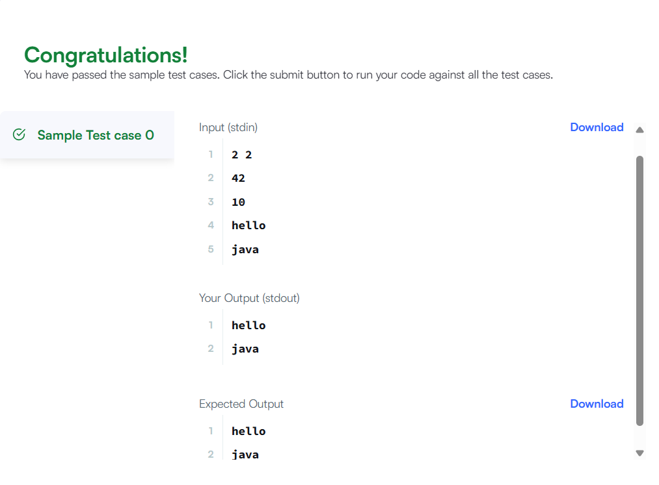
7. When a method in a subclass overrides a method in superclass, it is still possible to call the overridden method using super keyword. If you write super.func() to call the function func(), it will call the method that was defined in the superclass.
You are given a partially completed code in the editor. Modify the code so that the code prints the following text:
Hello I am a motorcycle, I am a cycle with an engine.
My ancestor is a cycle who is a vehicle with pedals.
Java code
class BiCycle {
String define_me() {
return "a vehicle with pedals.";
}
}

class MotorCycle extends BiCycle {
MotorCycle() {
System.out.println("Hello I am a motorcycle, I am a cycle with an engine.");
System.out.println("My ancestor is a cycle who is " + super.define_me());
}
@Override
String define_me() {
return "a motorcycle with an engine.";
}
}

public class Solution {
public static void main(String[] args) {
MotorCycle m = new MotorCycle();
}
}
Output

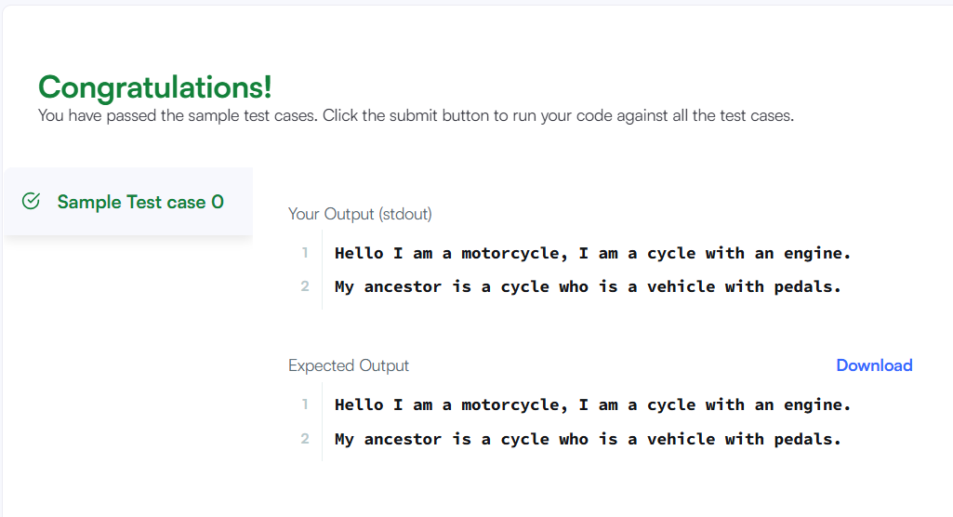

8. When a subclass inherits from a superclass, it also inherits its methods; however, it can also override the superclass methods (as well as declare and implement new ones). Consider the following Sports class:
Java code
class Sports {
String getName() {
return "Generic Sports";
}
void getNumberOfTeamMembers() {
System.out.println("Each team has n players in " + getName());
}
}
class Soccer extends Sports {
@Override
String getName() {
return "Soccer Class";
}
@Override
void getNumberOfTeamMembers() {
System.out.println("Each team has 11 players in " + getName());
}
}
public class Solution {
public static void main(String[] args) {
Sports c1 = new Sports();
Soccer c2 = new Soccer();
System.out.println(c1.getName());
c1.getNumberOfTeamMembers();
System.out.println(c2.getName());
c2.getNumberOfTeamMembers();
}
}
Output

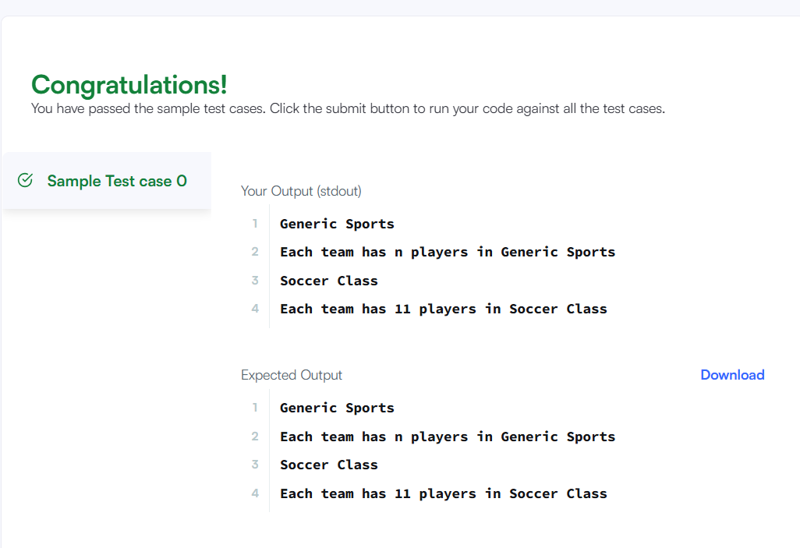
9. A Java interface can only contain method signatures and fields. The interface can be used to achieve polymorphism. In this problem, you will practice your knowledge on interfaces.
You are given an interface AdvancedArithmetic which contains a method signature int divisor_sum(int n). You need to write a class called MyCalculator which implements the interface.
divisorSum function just takes an integer as input and return the sum of all its divisors. For example divisors of 6 are 1, 2, 3 and 6, so divisor_sum should return 12. The value of n will be at most 1000.
Read the partially completed code in the editor and complete it. You just need to write the MyCalculator class only. Your class shouldn't be public.
Java code
import java.util.*;
interface AdvancedArithmetic {
int divisor_sum(int n);
}
class MyCalculator implements AdvancedArithmetic {

@Override
public int divisor_sum(int n) {
int sum = 0;
for (int i = 1; i <= n; i++) {
if (n % i == 0) {
sum += i;
}
}
return sum;
}
}
public class Solution {
public static void main(String[] args) {
Scanner sc = new Scanner(System.in);
int n = sc.nextInt();
MyCalculator my_calculator = new MyCalculator();

System.out.println("I implemented: AdvancedArithmetic");
System.out.println(my_calculator.divisor_sum(n));

sc.close();
}
}

Output

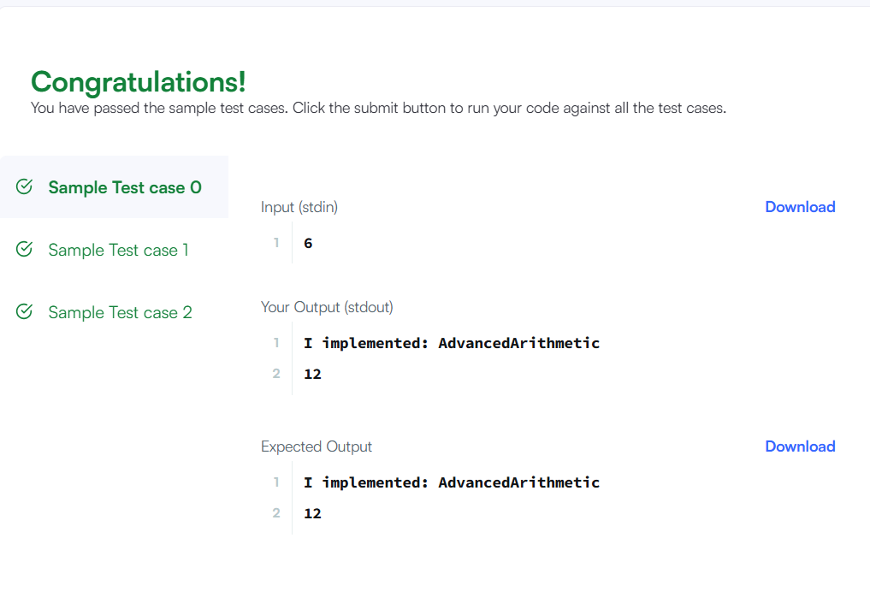
10. A Java abstract class is a class that can't be instantiated. That means you cannot create new instances of an abstract class. It works as a base for subclasses. You should learn about Java Inheritance before attempting this challenge.
Following is an example of abstract class:
Java code
import java.util.*;
abstract class Book {
String title;
abstract void setTitle(String s);
String getTitle() {
return title;
}
}
class MyBook extends Book {

@Override
void setTitle(String s) {
this.title = s;
}
}
public class Solution {
public static void main(String[] args) {
Scanner sc = new Scanner(System.in);

String title = sc.nextLine();

MyBook newNovel = new MyBook();
newNovel.setTitle(title);

System.out.println("The title is: " + newNovel.getTitle());

sc.close();
}
}
Output
